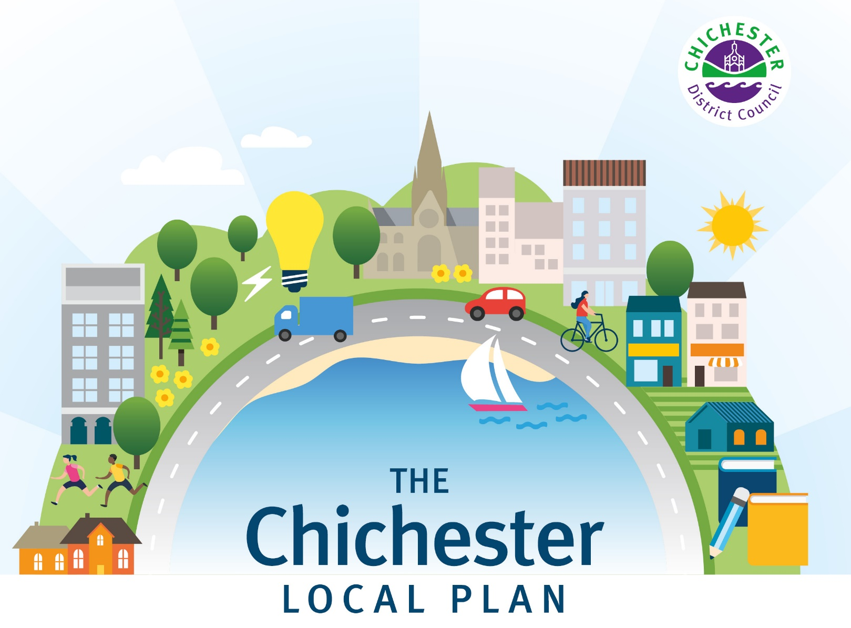

North of the plan area
A brief overview of the challenges facing the Local Plan, how we have addressed these, and key points relating to your area.

www.chichester.gov.uk/localplan

It’s nearly time to submit the Chichester Local Plan
We’re really pleased to let you know that after responding to your views and to the challenges we have faced, we’re nearly ready to submit our Local Plan to be examined.
You may remember that our current Local Plan was adopted in July 2015. Since then, a great deal has happened. The number of houses the Government requires us to build has changed numerous times and due to the issues we have faced, including the roads, waste water and water neutrality, we have had to carry out extensive work and research to test various options. This has involved significant background evidence studies, as well as consultation with you and our partners
Any council that submits their Local Plan to the Planning Inspector is required to show that they have tried and tested every possible way to reach the housing numbers set by Government. No stone can be left unturned. This means that the work that we have carried out to date has been vital in demonstrating the complex situation we are in.
We have been very clear that we believe this work shows that the Local Plan is unable to meet the full housing targets set by Government due to a lack of external funding for infrastructure improvements, specifically the A27. Due to this, we’ve lowered our housing numbers to what we believe is achievable, based on the evidence we have gathered.
We’ve always said that the roads, wastewater and water neutrality are the biggest challenges facing the plan. The Local Plan has to demonstrate that we have investigated all options and solutions before the Government will consider a lower housing target. We are now at this point.
This update is intended to provide a brief overview of the challenges facing the Local Plan, how we have addressed these and the key points relating to your area.

Consultation open from 3 February until 17 March 2023
You can take part in a very specific consultation between 3 February and 17 March at www.chichester.gov.uk/localplanconsultation This invites people to comment on three specific questions or tests. Respondents will be asked: if the plan has met the legal requirements; if it has been positively prepared and is justified, effective and consistent with national policy; and if the council has engaged and worked effectively with neighbouring authorities and statutory bodies. Once completed, all comments will be packaged alongside the plan for the Planning Inspector to consider as part of the independent examination on behalf of the Government. Please read pages 10 to 12 for more detail and advice on this.

Area: North of the plan area

Key points relating to your area
The north of the plan area covers those parts of Chichester District which lie north of the South Downs National Park boundary. This includes Loxwood Parish and most of the parishes of Kirdford, Plaistow and Ifold, and Wisborough Green. It also includes a small part of Lynchmere Parish, close to the Surrey border around the villages of Camelsdale and Hammer.
As part of the plan making process, we have to consider how many homes each area can accommodate. Higher housing numbers were considered at Loxwood, Kirdford, Wisborough Green and Plaistow and Ifold. However, this was ruled out due to the need to conserve the rural character of the area; its high-quality landscape; and, to minimise the impact on the historic environment.
Instead, the plan is suggesting that the following locations are able to accommodate a small number of homes through the neighbourhood planning process:

- Kirdford – 50 homes
- Wisborough Green – 75 homes
- Plaistow and Ifold – 25 homes
Loxwood is the least constrained village in the north of the plan area, and benefits from the most services and facilities, including healthcare. Due to this, it is proposed that 220 homes are delivered in Loxwood through the neighbourhood planning process.
Homes within the north of the plan area will need to demonstrate water neutrality through a mixture of water efficiency and offsetting. This is to limit the impact on the internationally designated Arun Valley sites, which are protected for their rare and protected habitats.

Challenges
Here are some of the key challenges we have been responding to and the approaches we have taken.
Roads
- We’ve gathered evidence which demonstrates that we cannot meet the Government’s housing targets.
- The number of houses will be limited in the south of the plan area due to the capacity constraints on the A27.
- We’ve employed consultants to create a transport model and options to show what is achievable.
- We’ve worked with our partners who are responsible for roads to develop plans for a new ‘monitor and manage’ approach to transport impacts. This will monitor what is actually taking place on the roads – rather than relying solely on modelled forecasts - and will deliver the best achievable mitigation measures.
- We’ve created plans for a series of road improvements to the local road network.
Due to the significant road improvements required to enable new housing growth to take place, and the fact that insufficient funding is available to deliver this, we will be explaining to the Planning Inspector that the plan will not meet the full housing targets set by Government. Instead, we have worked closely with National Highways and West Sussex County Council to establish a revised strategy based on improvements that can be delivered to the A27 during the plan period. Our partners have agreed with us that they believe the plan area can take 575 new homes per year as long as the capacity of the road network, including specific junctions on the A27, is improved and that other sustainable travel options are also introduced.
Wastewater
- We have worked closely with local water companies and pushed for improvements.
- The water companies are now preparing Drainage and Wastewater Management Plans.
- A Statement of Common Ground (a statement setting out the current position) has been agreed by Southern Water, Environment Agency and the council.
- Water companies are due to bring forward improvements.
Water companies have a statutory duty to treat wastewater from new development. We work closely with these companies, primarily Southern Water, but also Portsmouth and Thames Water, to ensure new development is factored into their future plans. The water companies are preparing the Drainage and Wastewater Management Plans, which look at the improvements needed over the next 25 years or more. Water companies are also due to bring forward improvements that are needed before 2025.
Wastewater disposal has long been a problem in the south of the district and we have been lobbying Southern Water to explain to us what improvements are required for some time.
Following an official complaint to the Water Services Regulation Authority, Ofwat, we have been holding constructive meetings with Southern Water and the Environment Agency, and Southern Water has agreed to work with us on identifying the improvements that need to be made.
We are continuing to work closely with Southern Water in particular, to confirm they can deliver the required improvements and to identify where phased delivery of housing might be needed. A first Statement of Common Ground (a statement setting out the current position) was agreed by the council, Southern Water and the Environment Agency was published in November 2021.
Water neutrality
- We have worked on a joint study with other planning authorities across West Sussex to find solutions to this problem.
- This work has informed the new water neutrality policy in the Local Plan.
Natural England has advised us that planning applications for new development on sites supplied by Southern Water from its Sussex North Water Resource Zone should demonstrate that they are water neutral.
Any planning application in the areas affected will need to demonstrate water neutrality through a mixture of water efficiency, and offsetting. This applies to any proposed development that would increase demand on the water supply including offices, shops and houses. We have issued advice on our website setting out requirements for proposals to achieve water neutrality.
A small part of the Chichester Local Plan area is currently affected by the requirement for water neutrality. Neighbouring planning authorities, including South Downs National Park Authority, Horsham District Council and Crawley Borough Council are also affected. The council has worked on a joint study with these authorities to quantify the scale of the issue and identify proposed mitigation schemes to address this. The results from the study have informed the water neutrality policy, which requires all development in the Sussex North Water Resource Zone to demonstrate water neutrality.

Where are we now?
In addition to resolving the challenges that we have faced, we have also carried out extensive work and studies on other areas covered by the plan. These include: housing; retail and economic development needs; wildlife corridors; flood risk; nitrate neutrality; and the needs of gypsy, traveller and travelling showpeople. This work, along with the consultation we have carried out with our partners, such as the Environment Agency and West Sussex County Council, has informed the approach we have taken within the latest version of the Local Plan.
Housing
The housing target set by the Government for our local plan area is 638 new homes each year. However, we are now proposing to meet a reduced number of 575 homes per year to take account of the challenges the plan area currently faces.
There’s a high demand for housing and we know that young people are finding it difficult to get on the property ladder as first-time buyers or renters. We want those who grow up here to have the option to stay here – and so we need to make sure that there are homes of the right prices and type that will enable us to do this. We also want to attract people to work here, in our hospitals, schools and other essential services. This is why we are supporting the Government’s First Homes scheme, which helps local first-time buyers and key workers onto the property ladder by offering homes at a discount of 30%. We are also proposing to vary the amount of affordable housing across the district, depending on the site and location. In some developments, this will increase to 40%, in some areas it remains at 30% and in a few areas it is 20%. This has been based on localised factors and the type of development site.

For the first time, we are also proposing that a proportion of land on new strategic sites will be allocated for self-build or custom build plots. This is something that many residents in our district are keen to see, and we are also hoping that the Government will release funding to help people to build their own home.

We are also ensuring that 5% of new affordable housing will be wheelchair accessible on all new housing developments. The remainder of new homes will have to be meet ‘accessible and adaptable’ standards, which allow homes to be more easily adapted if needed. Strategic sites will also be required to provide housing for older people who require support or care, to help meet the needs of the population as they age.
Economy
A key role of the plan is to look at employment space and places where retail should be provided. This is important because it helps to support the local economy. As jobs are created, earnings are increased, productivity is raised, living standards are improved, aspiration and skills are increased, and better quality of services and facilities for those living in and visiting our area are provided. We are proposing that the employment land identified in the 2015 Plan; retained employment land from the Site Allocation Development Plan Document; and a new employment site to the south of Bognor Road, will meet the employment needs in our plan area. The plan will also work alongside the Chichester Vision to help support the day and night-time economy, as well as continuing support for the horticultural industry. This will be achieved through retention of the Horticultural Development Areas, which will be expanded at Runcton.

Other reasons why the plan is so important
The Local Plan isn’t just about building new homes and creating new employment opportunities, it has an important role in creating a district that we can all be proud of and that meets local needs.
Climate Change and Natural Environment
We are incredibly lucky to live and work in such a beautiful and biodiverse area, and we want to keep it that way. The Local Plan looks to identify areas that need to be protected, such as valued countryside and open spaces. We have also produced a policy to protect wildlife corridors, which is the first time this type of initiative has been introduced in this area. The plan will require a 10% ‘biodiversity net gain’ which aims to improve the natural environment. The plan also accounts for the impacts of climate change by locating development in the right place and addressing the need to mitigate any flood risk associated with new development. The National Planning Policy Framework places a requirement on developers to consider the impacts of existing and future flood risk for the lifetime of a development. The Local Plan is based on a Strategic Flood Risk Assessment and sets out a strategy for appropriately mitigating flood risk within the plan area.

Getting around

This looks at how we move in and around the plan area. This includes making sure that the right roads and transport networks are in place. This is not a simple exercise because it requires us to carry out detailed assessments, accounting for all sorts of things - from the environmental impact to local economic needs. It’s also important to point out that although this is included in the Local Plan, we are not the agency responsible for roads and transport.

The Local Plan also supports sustainable transport and ensures that development proposals prioritise walking and cycling as forms of active travel. New development will support local authority planned walking and cycling improvements by contributing towards identified schemes, while ensuring it is well connected to key facilities and locations.

Place-making, health and wellbeing

One of the key aims of the Local Plan is to create safe and beautiful places by requiring high standards of design that respect local character and distinctiveness and make good use of land. The plan requires new development to be well designed, so it can be easily navigated, with high quality open spaces and landscaping. It is also expected to address issues such as noise pollution.

Our area also offers a wealth of heritage, and the Local Plan plays a vital role in protecting historic buildings and features. Where development is proposed that could affect a particular heritage asset, Local Plan policies can normally protect it as part of the overall development.

The Local Plan also has an important role to play in helping to support the health and wellbeing of our residents. We work closely with health care providers to identify what additional health facilities may be needed in areas where additional housing is being considered. If needed, financial contributions from developers, or land provided by the developer on a new site, can be used to ensure everyone has access to healthcare. The Local Plan also considers how developments should be designed to support a healthy lifestyle, with safe places to walk and cycle, and offering access to green spaces and sport and leisure facilities, all of which can help physical and mental wellbeing.

Local community

For each new home built, the Government gives the council a financial payment. Some of this money is ring fenced for those communities that deliver new homes. This is then used to improve their local facilities, for example the creation of a village hall or play area.

In addition to this, the Local Plan policies and community infrastructure levy means that developers have to pay a financial contribution, or provide infrastructure, for every property they build. This money is already being invested in villages and towns that are taking new developments, with new community facilities.

Education and learning

The Local Plan area has a good supply of pre-school, primary school and secondary school facilities. It is important to make sure that there is capacity within these schools to accommodate pupils from new development provided through the Local Plan.

We work closely with West Sussex County Council, which is the local Education Authority, to determine whether further capacity would be required and if it is, whether this can be delivered through the expansion of existing facilities or whether new schools are needed as part of a new development. New provision will usually be secured through developer contributions. In addition, Chichester College and the University of Chichester are both within the Local Plan area. These provide further and higher education facilities that offer opportunities for people to develop their skills and progress their learning. This can have an important and positive impact on the local economy by generating a more skilled and varied workforce and providing a range of jobs in each of the facilities.

Facilities and services

In order to deliver the Local Plan, the right services and facilities need to be in place. One of the biggest issues facing the plan is the need for more wastewater capacity. Wastewater has long been a problem in the South of the district and we have been lobbying Southern Water to explain what improvements are required for some time. We have been holding constructive meetings with Southern Water and the Environment Agency. Southern Water has agreed to work with us jointly on identifying improvements that need to be made.

Further information
We have provided further information, including a useful frequently asked questions page on our website at: www.chichester.gov.uk/localplanfaqs You can also find all of the evidence here too.

Tell us what you think
Your views are really important to us, and they are a vital part of producing the plan. You may remember within the last consultation we asked for your detailed views. Along with the evidence that we have gathered, we have used these comments to help shape a revised version of the plan.
We’re now running a very specific consultation between 3 February and 17 March 2023 which invites you to comment on three specific questions or tests at: www.chichester.gov.uk/localplanconsultation This is known as the Regulation 19 consultation phase and is the last stage before we submit the plan for examination.
The three questions or tests are:
- Is it legally compliant?
- Has the plan been included in the current Local Development Scheme and have the key stages set out in the Local Development Scheme been followed? The Local Development Scheme is effectively a programme of work prepared by the council, setting out the plans we will produce. It sets out the key stages in the production of any plans which we propose to bring forward for examination. If the plan is not in the current Local Development Scheme it should not have been published for consultation. Our Local Development Scheme can be found here: www.chichester.gov.uk/localdevelopmentscheme

- Has the process of community involvement for the plan followed our Statement of Community Involvement? The Statement of Community Involvement sets out our strategy for involving the community in the preparation and revision of plans and the consideration of planning applications. You can find our Statement of Community Involvement here: www.chichester.gov.uk/statementofcommunityinvolvement

- Has a Sustainability Appraisal report been produced? This is required when a plan is published and should identify the process by which the sustainability appraisal has been carried out, and the baseline information used to inform the process and the outcomes of that process. It is a tool for assessing the extent to which the plan, when judged against reasonable alternatives, will help to achieve relevant environmental, economic and social objectives.

- Does the plan comply with all other relevant requirements of the Planning and Compulsory Purchase Act 2004 and the Town and Country Planning (Local Planning) (England) Regulations 2012, as amended [the Regulations]?

- Is it Sound?
The tests of soundness are set out in paragraph 35 of the National Planning Policy Framework. Plans are sound if they are:
- Positively prepared – providing a strategy which, as a minimum, seeks to meet the area’s objectively assessed needs; and is informed by agreements with other authorities. This is so that unmet need from neighbouring areas is accommodated where it is practical to do so and is consistent with achieving sustainable development;
- Justified – an appropriate strategy, taking into account the reasonable alternatives, and based on proportionate evidence;
- Effective - deliverable over the plan period, and based on effective joint working on cross-boundary strategic matters that have been dealt with rather than deferred, as evidenced by the statement of common ground; and
- Consistent with national policy – enabling the delivery of sustainable development in accordance with the policies in the National Planning Policy Framework and other statements of national planning policy, where relevant.
If you think the content of the plan is not sound because it does not include a policy on a particular issue, you should go through the following steps before making representations:
- Is the issue with which you are concerned already covered specifically by national planning policy?
- Is the issue with which you are concerned already covered by another policy in this plan?
- If the policy is not covered elsewhere, in what way is the plan unsound without the policy?
- If the plan is unsound without the policy, what should the policy say?

- Does it comply with the Duty to Cooperate?
As part of the plan preparation process, we are required to engage constructively, actively and on an ongoing basis with neighbouring authorities and certain other bodies over strategic matters during the preparation of the plan. We are expected to provide evidence of how we have complied with the duty.
Non-compliance with the duty to co-operate cannot be rectified after the submission of the plan. The Inspector has no power to recommend modifications in this regard. Where the duty has not been complied with, the Inspector cannot recommend adoption of the plan.

For more advice on taking part in this consultation, visit: www.chichester.gov.uk/localplan

Submitting your comments
You can view our revised local plan at www.chichester.gov.uk/localplanconsultation and at our offices at East Pallant House, East Pallant Chichester from 3 February 2023.
If you wish to make comments relating to legal compliance, the ‘tests of soundness’ and compliance with the Duty to Cooperate, then you will need to register for an account on our consultation platform. You can find a step-by-step guide here: www.chichester.gov.uk/article/37208/View-and-comment-on-the-emerging-Local-Plan
If you do not have access to a computer, you can either use our computers in our reception at our East Pallant House offices or you can request a paper copy by calling: 01243 785166.
Reference copies of the plan and key supporting documents are available at our offices at East Pallant House, East Pallant, in Chichester.
The consultation begins on Friday 3 February and comments must be received no later than 5pm on Friday 17 March 2023.
The feedback you provide will be packaged alongside the proposed plan and submitted to the Planning Inspector.
The Planning Inspector will then review the plan as part of the examination process and then hopefully this will be approved and adopted.

Timeline
Stage one – Issues and Options - completed
Stage One of the process was carried out in June 2017 with an Issues and Options consultation, in which we invited you to complete a questionnaire regarding the overall development strategy and possible development locations. These responses were used to help draft our Preferred Approach Plan.
Stage two – Preferred Approach - completed
For The Local Plan Review, the preferred approach is the second stage of the process. It sets out the proposed development strategy and policies for the area to meet future needs. We invited you to make comments on our preferred approach between December 2018 and February 2019. These responses, along with the further evidence we have gathered, have been used to help draft a revised version of the plan.
Stage three – Regulation 19 and submission - current
We have considered your feedback from Stage two and have made changes to the plan. We are now inviting you to comment on three specific questions or tests – legal compliant, soundness and duty to cooperate. Your comments will then be submitted alongside the plan to the government for independent examination.
Stage four – Examination - future
A planning inspector will be chosen by the government to examine our plan and they will then report on their findings. There may be further changes to the plan which are required as a result of the hearing sessions held with the inspector. These changes are called ‘main modifications’ and there will be a six-week consultation before the examination ends.
Stage five – Adoption - future
We will adopt the Local Plan once the planning inspector is happy with it.

Planning Policy
East Pallant House,
1 East Pallant, Chichester,
West Sussex PO19 1TY

